Pathways to Career Readiness:
An Education and Workforce Development Symposium

REQUEST FOR PRESENTATIONS

31st ANNUAL SYMPOSIUM
Hershey Lodge and Convention Center

The Annual Symposium will be held on February 10 and 11, 2022 at the Hershey Lodge and Convention Center. The Symposium will begin at 12:30 p.m. on February 10, 2022 and will conclude at noon on February 11, 2022. In addition to dynamic general session speakers, we will be offering a number of one-hour small group sessions.

Small group sessions are your chance to present your best practices and programs. If you are interested in presenting at the Symposium, please complete the attached form. Then please submit it no later than
November 5, 2021 to: pacta.presentations@gmail.com

For more information please contact John Pulver, Associate Director
Contact information: john@pacareertech.org or (272) 202-3675.

Thank you for considering this invitation to present at the
2022 Pathways to Career Readiness Symposium.

NOTE
All presenters are expected to be registered for the Symposium.

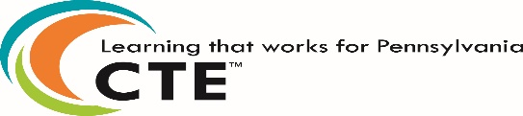

The 31st Annual Symposium
Pathways to Career Readiness:
An Education and Workforce Development Symposium
February 10 and 11, 2022
Hershey Lodge and Convention Center

PRESENTATION DESCRIPTION FORM

NOTE: ALL PRESENTATIONS MUST ADDRESS
THE CONFERENCE THEME

PRESENTATIONS WILL NEED TO BE ONE HOUR

1. Title of Presentation:

2. First Presenter’s Name:

(If there are more than two presenters, please provide the relevant information on another sheet of paper and attach it to this form.)

Title:
Agency:
Address:

City:
State: Zip:
Telephone Number:
Fax:
E-mail:

3. Second Presenter’s Name:

Title:
Agency:
Address:

City:
State: Zip:
Telephone Number:
Fax:
E-mail

4. Equipment Needs: (Please check all that apply)

____ Flipchart

____ Internet

(All session rooms will be equipped with a laptop and projector)

6. Description of Program (Note: Description should be 75-100 words in length):

7. Individual to contact if further information is needed:

Name: ____________________________________________

Telephone Number: __________________________________

E-mail: ____________________________________________

Please submit this form by November 5, 2021 to:

pacta.presentations@gmail.com

