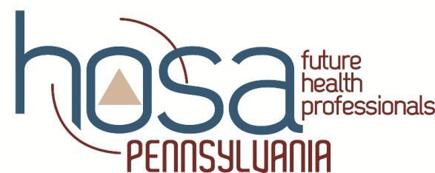

Child Abuse and Molestation Policy
Administrative Guidelines
For
PENN HOSA State Leadership Conference

School Advisors and Chaperones shall submit the PENN HOSA Assurance Statement as evidence of compliance with PA Act 15 of 2015 and PA Act 126 of 2012.
Judges, Guests and Other Short-Term Visitors shall not be required to comply with PA Act 15 of 2015 and PA Act 126 of 2012.
Overnight volunteers shall submit the following volunteer certifications to the Executive Director for file and audit:
Pennsylvania State Police Report of Criminal History
Pennsylvania Department of Human Services Child Abuse History Certification

Volunteers may apply for the required certifications free of charge at: http://www.compass.state.pa.us/CWIS.

